E-commerce

Our website is selling a number of types of products, under the name of e-commerce.

It contains 6 pages.

1. Home page: It contains location information, contact information and ownership, and displays a number of pictures.

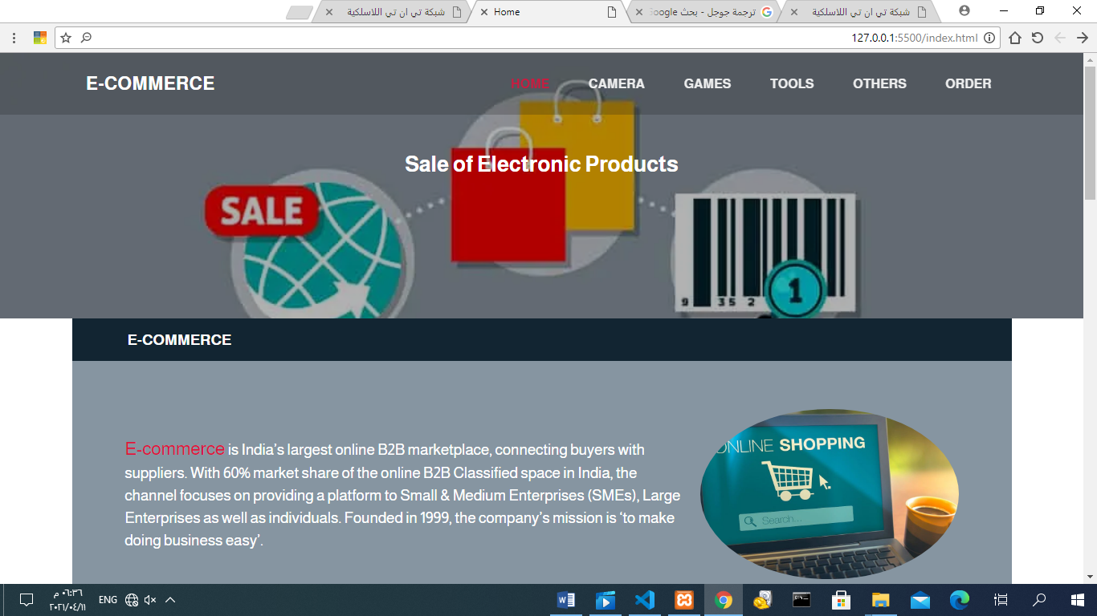

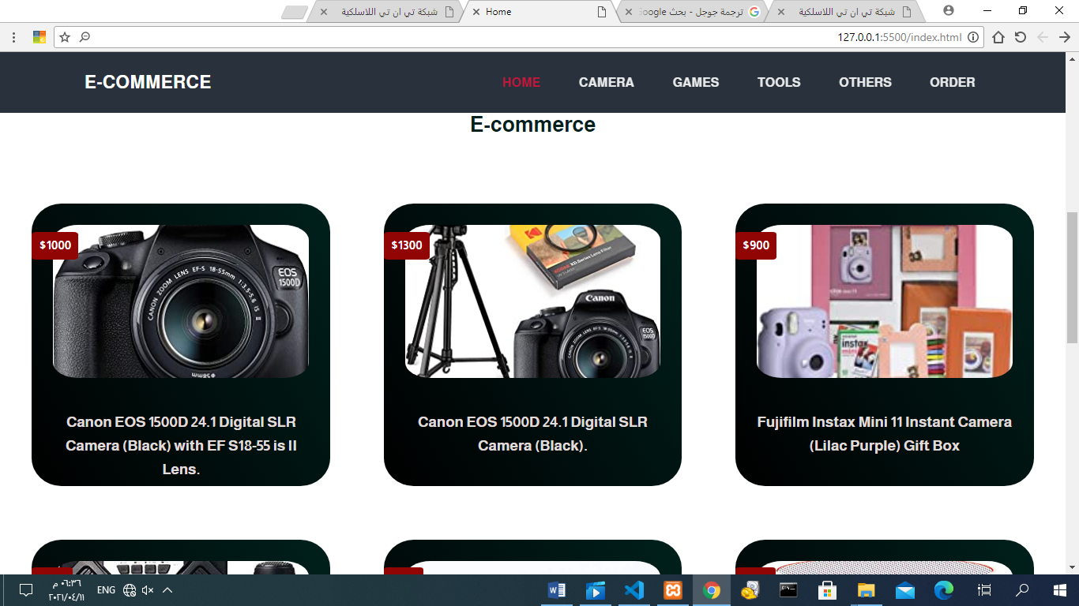

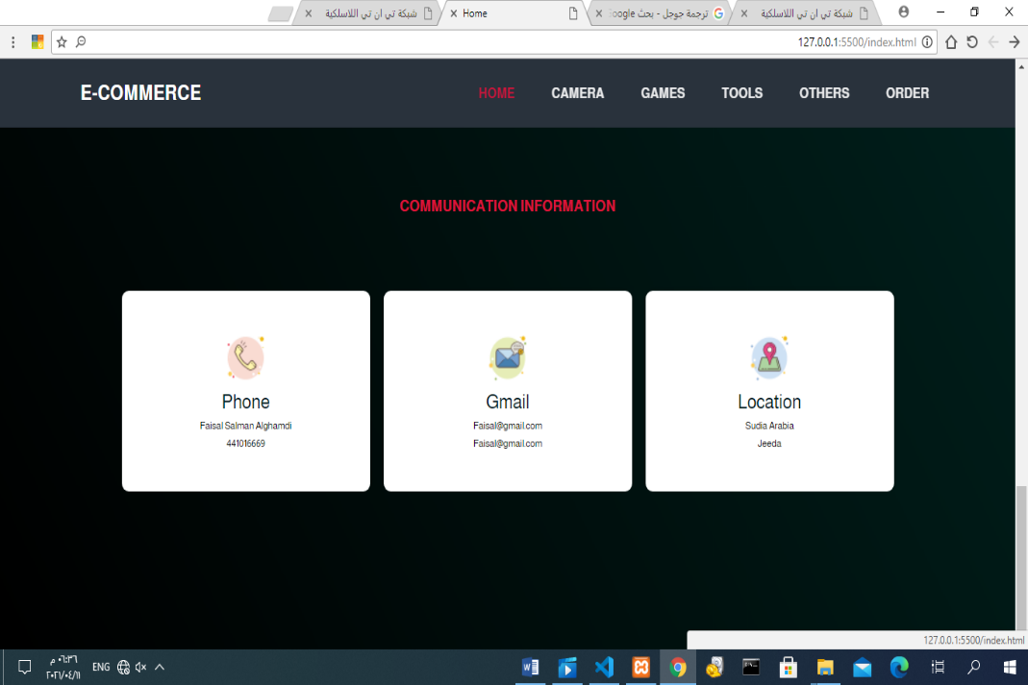

1. Cameras page: displays a list of image links related to camera products.

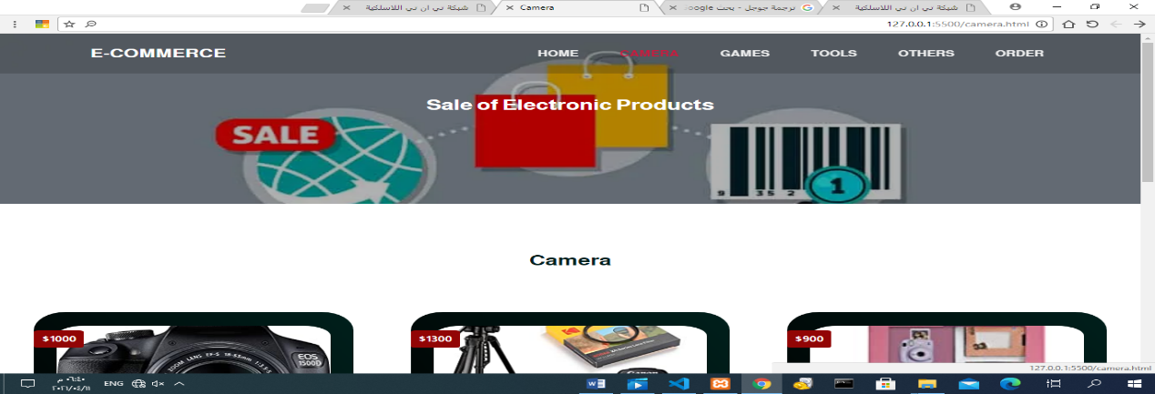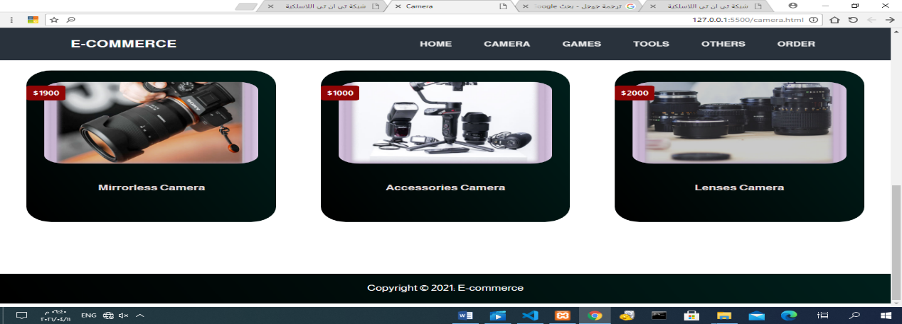

1. Games page: it is the same as the cameras page

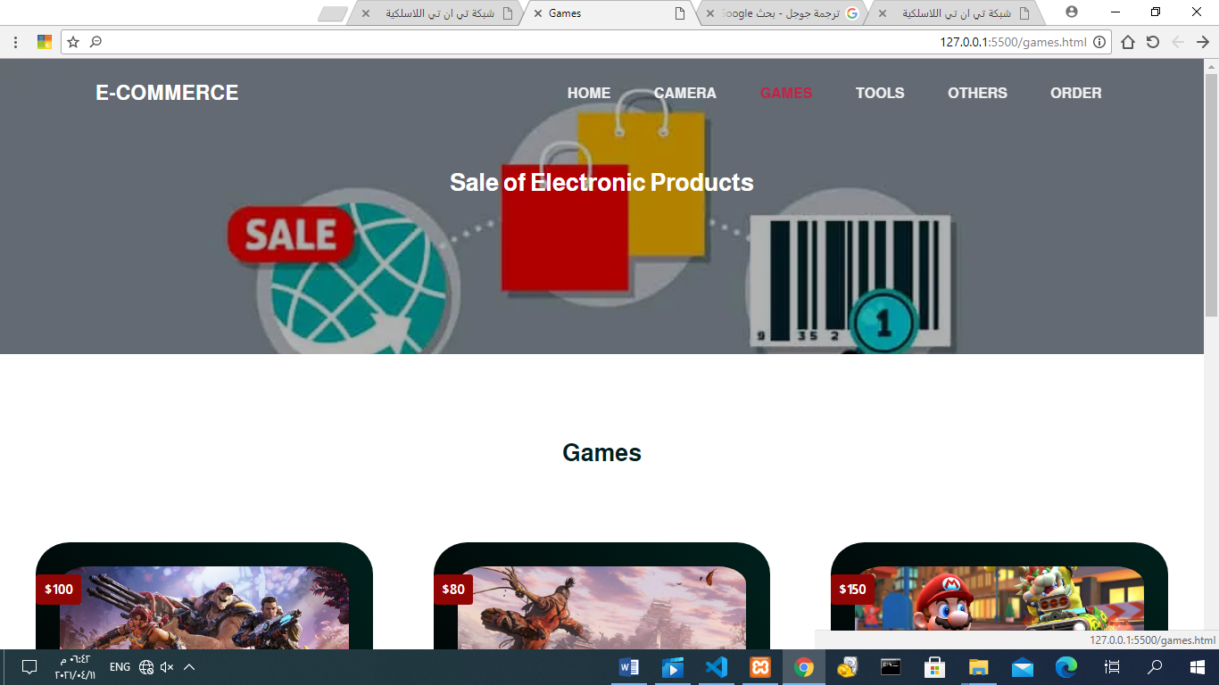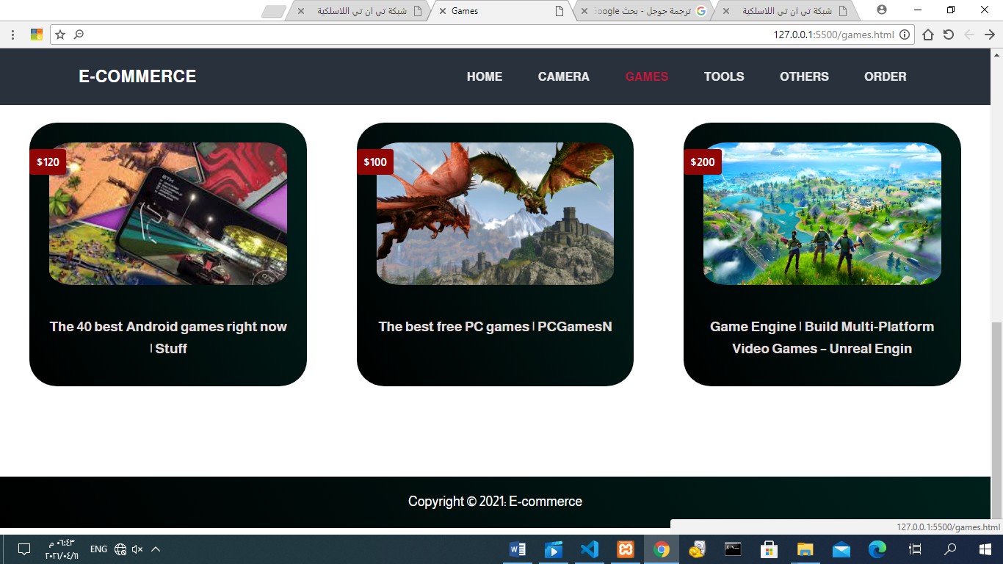

1. Building tools page: the same thing. 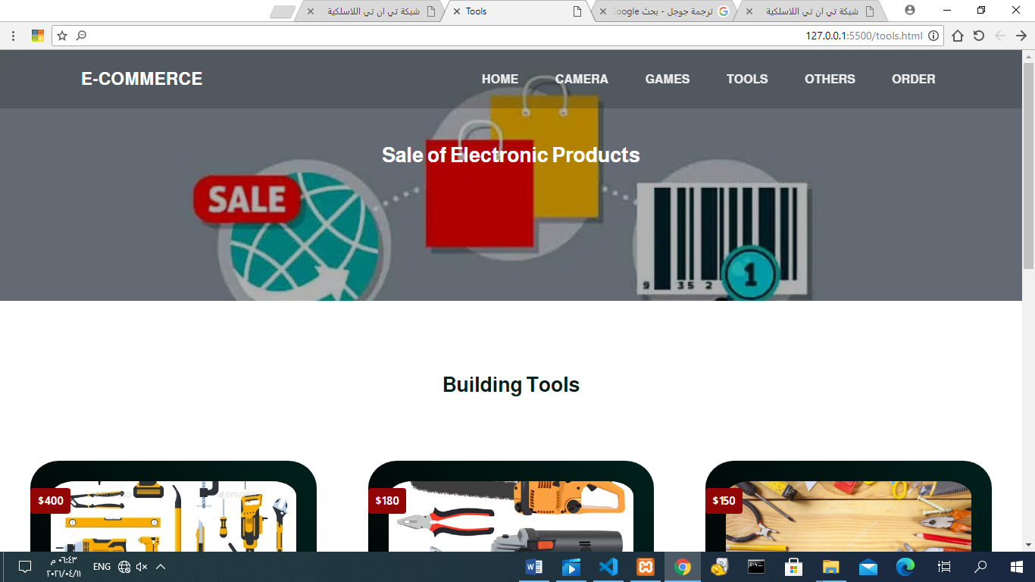

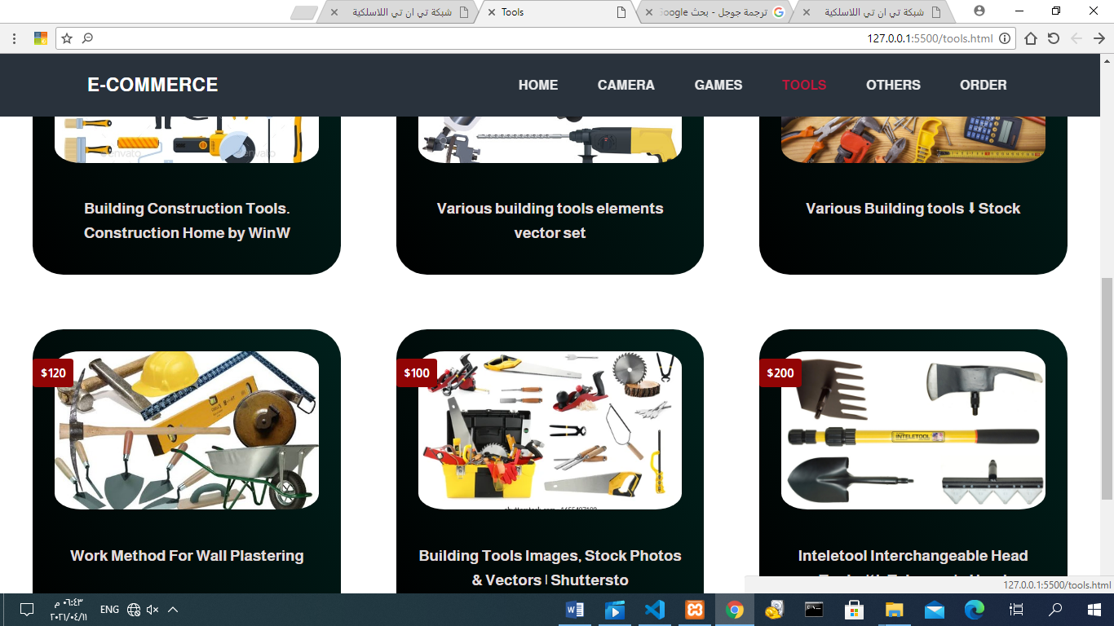

1. A page called Others: It displays different types of products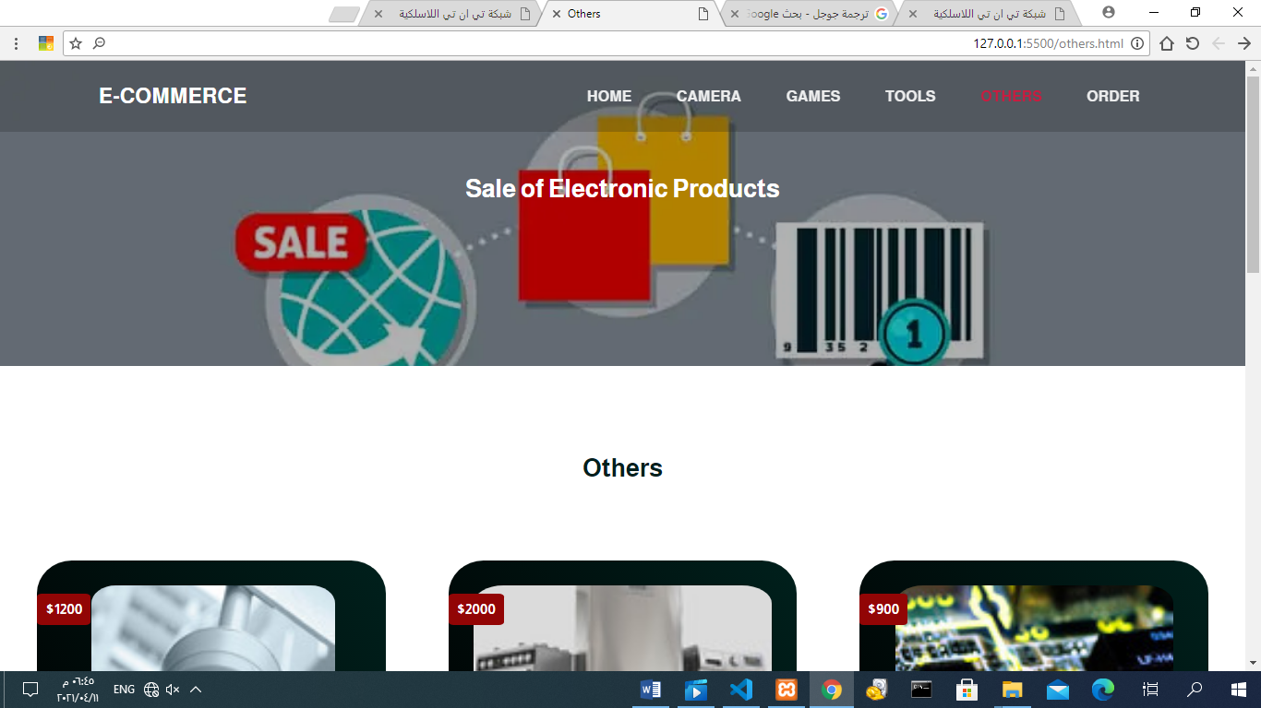.

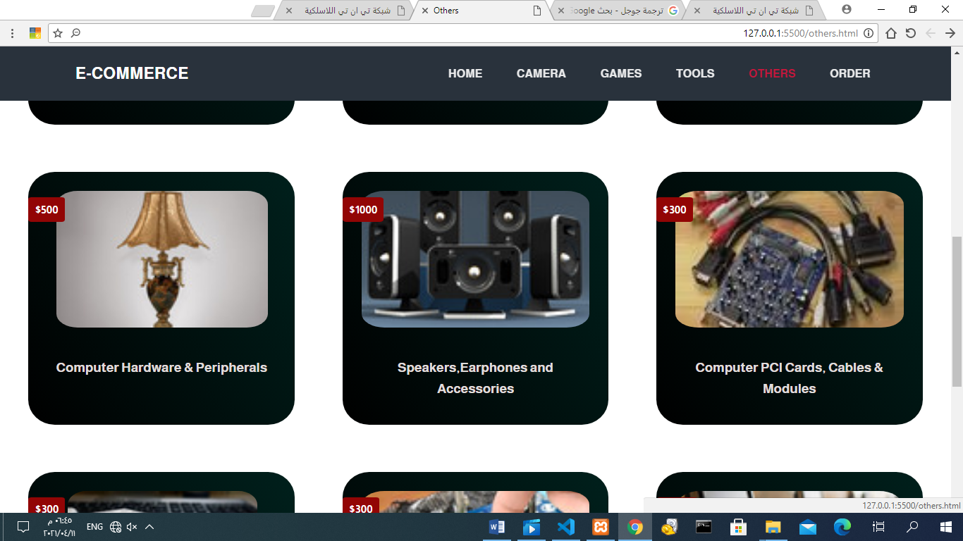

1. Order page: Requires information about the user to purchase the product

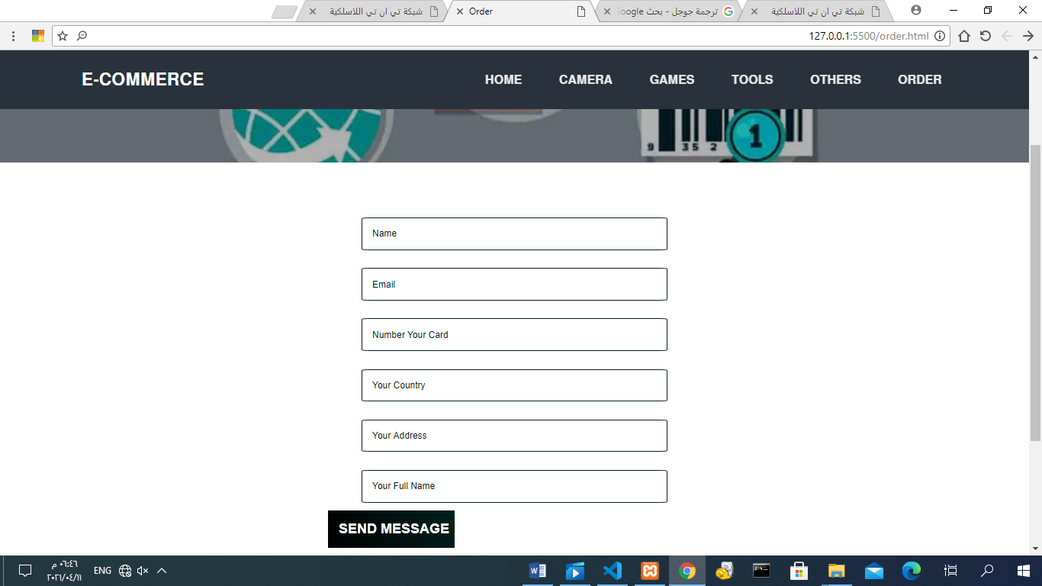

* HTML Code:

1. Home Page
2. <!DOCTYPE html>
3. <html lang="en">
4. <head>
5. <meta charset="UTF-8">
6. <meta name="viewport" content="width=device-width, initial-scale=1.0">
7. <title>Home</title>
8. <link rel="stylesheet" href="css/style.css">
9. </head>
10. <body>
11. <!-- Start Navbar -->
12. <section id="header">
13. <div class="header container">
14. <div class="nav-bar">
15. <div class="brand">
16. <a href="index.html"><h1>E-commerce</h1></a>
17. </div>
18. <div class="nav-list">
19. <div class="hamburger"><div class="bar"></div></div>
20. <ul>
21. <li><a href="index.html" data-after="Home">Home</a></li>
22. <li><a href="camera.html" data-after="Services">Camera</a></li>
23. <li><a href="games.html" data-after="Sbout">Games</a></li>
24. <li><a href="tools.html" data-after="Sbout">Tools</a></li>
25. <li><a href="others.html" data-after="Sbout">Others</a></li>
26. <li><a href="order.html" data-after="Contact">Order</a></li>
27. </ul>
28. </div>
29. </div>
30. </div>
31. </section>
32. <!-- End Navbar -->
33. <!-- Start Header section -->
34. <section id="homepage">
35. <div class="homepage container">
36. <div class="homepage-info">
37. <h1>Sale of Electronic Products<span></span></h1>
38. </div>
39. </div>
40. </section>
41. <section id="prog">
42. <div class="prog container">
43. <div class="top">
44. <h1>E-commerce</h1>
45. </div>
46. <div class="botton">
47. <p>
48. <span>E-commerce</span> is India’s largest online B2B marketplace, connecting buyers with suppliers.
49. With 60% market share of the online B2B Classified space in India, the
50. channel focuses on providing a platform to Small & Medium Enterprises
51. (SMEs), Large Enterprises as well as individuals. Founded in 1999, the
52. company’s mission is ‘to make doing business easy’.
53. </p>
54. <img src="image/e-commerce.jpg" alt="">
55. </div>
56. </div>
57. </section>
58. <!-- End  header Section -->
59. <!-- Start gallery Section -->
60. <div id="gallery">
61. <div class="gallery container">
62. <div class="gallery-top">
63. <h1>E-commerce</h1>
64. </div>
65. <div class="gallery-button">
67. <div class="gallery-item">
68. <a href="#">
69. <div class="prices">$1000</div>
70. <div class="icon">
71. <img src="image/ca1.jpg" alt="">
72. </div>
74. <div class="contaxt">
75. <h1>Canon EOS 1500D 24.1 Digital SLR Camera (Black) with EF S18-55 is II Lens.</h1>
76. </div>
77. </a>
78. </div>
80. <div class="gallery-item">
81. <a href="#">
82. <div class="prices">$1300</div>
83. <div class="icon">
84. <img src="image/ca2.jpg" alt="">
85. </div>
86. <div class="contaxt">
87. <h1>Canon EOS 1500D 24.1 Digital SLR Camera (Black).</h1>
88. </div>
89. </a>
90. </div>
91. <div class="gallery-item">
92. <a href="#">
93. <div class="prices">$900</div>
94. <div class="icon">
95. <img src="image/ca3.jpg" alt="">
96. </div>
97. <div class="contaxt">
98. <h1>Fujifilm Instax Mini 11 Instant Camera (Lilac Purple) Gift Box</h1>
99. </div>
100. </a>
101. </div>
102. <div class="gallery-item">
103. <a href="#">
104. <div class="prices">$200</div>
105. <div class="icon">
106. <img src="image/ha3.jpg" alt="">
107. </div>
108. <div class="contaxt">
109. <h1>ARNA BT Speaker 20 watts Bluetooth Party Speaker </h1>
110. </div>
111. </a>
112. </div>
113. <div class="gallery-item">
114. <a href="#">
115. <div class="prices">$100</div>
116. <div class="icon">
117. <img src="image/ha2.jpg" alt="">
118. </div>
119. <div class="contaxt">
120. <h1>A 005ABC Handheld Bluetooth Speaker with Super </h1>
121. </div>
122. </a>
123. </div>
124. <div class="gallery-item">
125. <a href="#">
126. <div class="prices">$500</div>
127. <div class="icon">
128. <img src="image/ha1.jpg" alt="">
129. </div>
130. <div class="contaxt">
131. <h1>Pikyo KDK22 Mini Pocket Size Wireless Bluetooth </h1>
132. </div>
133. </a>
134. </div>
135. </div>
136. </div>
137. </div>
138. <!-- End gallery Section -->
139. <!-- Start Footer -->
140. <section id="footer">
141. <div class="footer container">
142. <div class="contact-header"><h1>Communication Information</h1></div>
143. <div class="contact-items">
144. <div class="contact-item">
145. <div class="icon">
146. <img src="image/icon3.png" alt="">
147. </div>
148. <div class="contact-info">
149. <h1>Phone</h1>
150. <h2>Faisal Salman Alghamdi</h2>
151. <h2>441016669</h2>
152. </div>
153. </div>
154. <div class="contact-item">
155. <div class="icon">
156. <img src="image/icon1.png" alt="">
157. </div>
158. <div class="contact-info">
159. <h1>Gmail</h1>
160. <h2>Faisal@gmail.com</h2>
161. <h2>Faisal@gmail.com</h2>
162. </div>
163. </div>
164. <div class="contact-item">
165. <div class="icon">
166. <img src="image/icon2.png" alt="">
167. </div>
168. <div class="contact-info">
169. <h1>Location</h1>
170. <h2>Sudia Arabia</h2>
171. <h2>Jeeda</h2>
172. </div>
173. </div>
174. </div>
175. </div>
176. </section>


180. <!-- End Footer -->
181. <script src="js/app.js"></script>
182. </body>
183. </html>

2- Cameras Page:

<!DOCTYPE html>

<html lang="en">

<head>

    <meta charset="UTF-8">

    <meta name="viewport" content="width=device-width, initial-scale=1.0">

    <title>Camera</title>

    <link rel="stylesheet" href="css/style.css">

</head>

<body>

    <!-- Start Navbar -->

    <section id="header">

        <div class="header container">

            <div class="nav-bar">

                <div class="brand">

                    <a href="index.html"><h1>E-commerce</h1></a>

                </div>

                <div class="nav-list">

                    <div class="hamburger"><div class="bar"></div></div>

                    <ul>

                        <li><a href="index.html" data-after="Home">Home</a></li>

                        <li><a href="camera.html" data-after="Services">Camera</a></li>

                        <li><a href="games.html" data-after="Sbout">Games</a></li>

                        <li><a href="tools.html" data-after="Sbout">Tools</a></li>

                        <li><a href="others.html" data-after="Sbout">Others</a></li>

                        <li><a href="order.html" data-after="Contact">Order</a></li>

                    </ul>

                </div>

            </div>

        </div>

    </section>

    <!-- End Navbar -->

    <!-- Start Header section -->

    <section id="homepage">

        <div class="homepage container">

            <div class="homepage-info">

                <h1>Sale of Electronic Products<span></span></h1>

            </div>

        </div>

    </section>

    <!-- End  header Section -->

    <!-- Start gallery Section -->

    <div id="gallery">

        <div class="gallery container">

            <div class="gallery-top">

                <h1>Camera</h1>

            </div>

            <div class="gallery-button">

                <div class="gallery-item">

                    <a href="#">

                    <div class="prices">$1000</div>

                    <div class="icon">

                        <img src="image/ca1.jpg" alt="">

                    </div>

                    <div class="contaxt">

                        <h1>Canon EOS 1500D 24.1 Digital SLR Camera (Black) with EF S18-55 is II Lens.</h1>

                    </div>

                    </a>

                </div>

                <div class="gallery-item">

                    <a href="#">

                        <div class="prices">$1300</div>

                        <div class="icon">

                            <img src="image/ca2.jpg" alt="">

                        </div>

                        <div class="contaxt">

                            <h1>Canon EOS 1500D 24.1 Digital SLR Camera (Black).</h1>

                        </div>

                    </a>

                </div>

                <div class="gallery-item">

                    <a href="#">

                        <div class="prices">$900</div>

                        <div class="icon">

                            <img src="image/ca3.jpg" alt="">

                        </div>

                        <div class="contaxt">

                            <h1>Fujifilm Instax Mini 11 Instant Camera (Lilac Purple) Gift Box</h1>

                        </div>

                    </a>

                </div>

                <div class="gallery-item">

                    <a href="#">

                        <div class="prices">$1900</div>

                        <div class="icon">

                            <img src="image/ca5.jpg" alt="">

                        </div>

                        <div class="contaxt">

                            <h1>Mirrorless Camera</h1>

                        </div>

                    </a>

                </div>

                <div class="gallery-item">

                    <a href="#">

                        <div class="prices">$1000</div>

                        <div class="icon">

                            <img src="image/ca6.jpg" alt="">

                        </div>

                        <div class="contaxt">

                            <h1>Accessories Camera</h1>

                        </div>

                    </a>

                </div>

                <div class="gallery-item">

                    <a href="#">

                        <div class="prices">$2000</div>

                        <div class="icon">

                            <img src="image/ca7.jpg" alt="">

                        </div>

                        <div class="contaxt">

                            <h1>Lenses Camera  </h1>

                        </div>

                    </a>

                </div>

            </div>

        </div>

    </div>

    <!-- End gallery Section -->

    <!-- Start Contact Section -->

    <section id="contact">

        <div class="contact container">

            <p>Copyright &copy 2021: E-commerce</p>

        </div>

    </section>

    <!-- End Contact Section -->

<script src="js/app.js"></script>

</body>

</html>

3- Games Page

<!DOCTYPE html>

<html lang="en">

<head>

    <meta charset="UTF-8">

    <meta name="viewport" content="width=device-width, initial-scale=1.0">

    <title>Games</title>

    <link rel="stylesheet" href="css/style.css">

</head>

<body>

    <!-- Start Navbar -->

    <section id="header">

        <div class="header container">

            <div class="nav-bar">

                <div class="brand">

                    <a href="index.html"><h1>E-commerce</h1></a>

                </div>

                <div class="nav-list">

                    <div class="hamburger"><div class="bar"></div></div>

                    <ul>

                        <li><a href="index.html" data-after="Home">Home</a></li>

                        <li><a href="camera.html" data-after="Services">Camera</a></li>

                        <li><a href="games.html" data-after="Sbout">Games</a></li>

                        <li><a href="tools.html" data-after="Sbout">Tools</a></li>

                        <li><a href="others.html" data-after="Sbout">Others</a></li>

                        <li><a href="order.html" data-after="Contact">Order</a></li>

                    </ul>

                </div>

            </div>

        </div>

    </section>

    <!-- End Navbar -->

    <!-- Start Header section -->

    <section id="homepage">

        <div class="homepage container">

            <div class="homepage-info">

                <h1>Sale of Electronic Products<span></span></h1>

            </div>

        </div>

    </section>

    <!-- End  header Section -->

    <!-- Start gallery Section -->

    <div id="gallery">

        <div class="gallery container">

            <div class="gallery-top">

                <h1>Games</h1>

            </div>

            <div class="gallery-button">

                <div class="gallery-item">

                    <a href="#">

                    <div class="prices">$100</div>

                    <div class="icon">

                        <img src="image/g1.jpg" alt="">

                    </div>

                    <div class="contaxt">

                        <h1>Amazon Crucible: 'Can games be as fun to watch as they are to pl</h1>

                    </div>

                    </a>

                </div>

                <div class="gallery-item">

                    <a href="#">

                        <div class="prices">$80</div>

                        <div class="icon">

                            <img src="image/g2.jpg" alt="">

                        </div>

                        <div class="contaxt">

                            <h1>The Best Video Games Of 2019 [Updated]‏</h1>

                        </div>

                    </a>

                </div>

                <div class="gallery-item">

                    <a href="#">

                        <div class="prices">$150</div>

                        <div class="icon">

                            <img src="image/g3.jpeg" alt="">

                        </div>

                        <div class="contaxt">

                            <h1>From Cardboards To Phone Screens</h1>

                        </div>

                    </a>

                </div>

                <div class="gallery-item">

                    <a href="#">

                        <div class="prices">$120</div>

                        <div class="icon">

                            <img src="image/g4.jpg" alt="">

                        </div>

                        <div class="contaxt">

                            <h1>The 40 best Android games right now | Stuff‏</h1>

                        </div>

                    </a>

                </div>

                <div class="gallery-item">

                    <a href="#">

                        <div class="prices">$100</div>

                        <div class="icon">

                            <img src="image/g5.jpg" alt="">

                        </div>

                        <div class="contaxt">

                            <h1>The best free PC games | PCGamesN‏</h1>

                        </div>

                    </a>

                </div>

                <div class="gallery-item">

                    <a href="#">

                        <div class="prices">$200</div>

                        <div class="icon">

                            <img src="image/g6.jpg" alt="">

                        </div>

                        <div class="contaxt">

                            <h1>Game Engine | Build Multi-Platform Video Games – Unreal Engin</h1>

                        </div>

                    </a>

                </div>

            </div>

        </div>

    </div>

    <!-- End gallery Section -->

    <!-- Start Contact Section -->

    <section id="contact">

        <div class="contact container">

            <p>Copyright &copy 2021: E-commerce</p>

        </div>

    </section>

    <!-- End Contact Section -->

<script src="js/app.js"></script>

</body>

</html>

4- Tools Page

<!DOCTYPE html>

<html lang="en">

<head>

    <meta charset="UTF-8">

    <meta name="viewport" content="width=device-width, initial-scale=1.0">

    <title>Tools</title>

    <link rel="stylesheet" href="css/style.css">

</head>

<body>

    <!-- Start Navbar -->

    <section id="header">

        <div class="header container">

            <div class="nav-bar">

                <div class="brand">

                    <a href="index.html"><h1>E-commerce</h1></a>

                </div>

                <div class="nav-list">

                    <div class="hamburger"><div class="bar"></div></div>

                    <ul>

                        <li><a href="index.html" data-after="Home">Home</a></li>

                        <li><a href="camera.html" data-after="Services">Camera</a></li>

                        <li><a href="games.html" data-after="Sbout">Games</a></li>

                        <li><a href="tools.html" data-after="Sbout">Tools</a></li>

                        <li><a href="others.html" data-after="Sbout">Others</a></li>

                        <li><a href="order.html" data-after="Contact">Order</a></li>

                    </ul>

                </div>

            </div>

        </div>

    </section>

    <!-- End Navbar -->

    <!-- Start Header section -->

    <section id="homepage">

        <div class="homepage container">

            <div class="homepage-info">

                <h1>Sale of Electronic Products<span></span></h1>

            </div>

        </div>

    </section>

    <!-- End  header Section -->

    <!-- Start gallery Section -->

    <div id="gallery">

        <div class="gallery container">

            <div class="gallery-top">

                <h1>Building Tools</h1>

            </div>

            <div class="gallery-button">

                <div class="gallery-item">

                    <a href="#">

                    <div class="prices">$400</div>

                    <div class="icon">

                        <img src="image/t1.jpg" alt="">

                    </div>

                    <div class="contaxt">

                        <h1>Building Construction Tools. Construction Home by WinW</h1>

                    </div>

                    </a>

                </div>

                <div class="gallery-item">

                    <a href="#">

                        <div class="prices">$180</div>

                        <div class="icon">

                            <img src="image/t2.jpg" alt="">

                        </div>

                        <div class="contaxt">

                            <h1>Various building tools elements vector set</h1>

                        </div>

                    </a>

                </div>

                <div class="gallery-item">

                    <a href="#">

                        <div class="prices">$150</div>

                        <div class="icon">

                            <img src="image/t3.jpg" alt="">

                        </div>

                        <div class="contaxt">

                            <h1>Various Building tools ⬇ Stock</h1>

                        </div>

                    </a>

                </div>

                <div class="gallery-item">

                    <a href="#">

                        <div class="prices">$120</div>

                        <div class="icon">

                            <img src="image/t6.jpg" alt="">

                        </div>

                        <div class="contaxt">

                            <h1>Work Method For Wall Plastering‏</h1>

                        </div>

                    </a>

                </div>

                <div class="gallery-item">

                    <a href="#">

                        <div class="prices">$100</div>

                        <div class="icon">

                            <img src="image/t4.jpg" alt="">

                        </div>

                        <div class="contaxt">

                            <h1>Building Tools Images, Stock Photos & Vectors | Shuttersto</h1>

                        </div>

                    </a>

                </div>

                <div class="gallery-item">

                    <a href="#">

                        <div class="prices">$200</div>

                        <div class="icon">

                            <img src="image/t5.jpg" alt="">

                        </div>

                        <div class="contaxt">

                            <h1>Inteletool Interchangeable Head Tool with Telescopic Hand</h1>

                        </div>

                    </a>

                </div>

            </div>

        </div>

    </div>

    <!-- End gallery Section -->

    <!-- Start Contact Section -->

    <section id="contact">

        <div class="contact container">

            <p>Copyright &copy 2021: E-commerce</p>

        </div>

    </section>

    <!-- End Contact Section -->

<script src="js/app.js"></script>

</body>

</html>

5- Others Page

<!DOCTYPE html>

<html lang="en">

<head>

    <meta charset="UTF-8">

    <meta name="viewport" content="width=device-width, initial-scale=1.0">

    <title>Others</title>

    <link rel="stylesheet" href="css/style.css">

</head>

<body>

    <!-- Start Navbar -->

    <section id="header">

        <div class="header container">

            <div class="nav-bar">

                <div class="brand">

                    <a href="index.html"><h1>E-commerce</h1></a>

                </div>

                <div class="nav-list">

                    <div class="hamburger"><div class="bar"></div></div>

                    <ul>

                        <li><a href="index.html" data-after="Home">Home</a></li>

                        <li><a href="camera.html" data-after="Services">Camera</a></li>

                        <li><a href="games.html" data-after="Sbout">Games</a></li>

                        <li><a href="tools.html" data-after="Sbout">Tools</a></li>

                        <li><a href="others.html" data-after="Sbout">Others</a></li>

                        <li><a href="order.html" data-after="Contact">Order</a></li>

                    </ul>

                </div>

            </div>

        </div>

    </section>

    <!-- End Navbar -->

    <!-- Start Header section -->

    <section id="homepage">

        <div class="homepage container">

            <div class="homepage-info">

                <h1>Sale of Electronic Products<span></span></h1>

            </div>

        </div>

    </section>

    <!-- End  header Section -->

    <!-- Start gallery Section -->

    <div id="gallery">

        <div class="gallery container">

            <div class="gallery-top">

                <h1>Others</h1>

            </div>

            <div class="gallery-button">

                <div class="gallery-item">

                    <a href="#">

                    <div class="prices">$1200</div>

                    <div class="icon">

                        <img src="image/o1.jpg" alt="">

                    </div>

                    <div class="contaxt">

                        <h1>Safety Equipment & Systems.</h1>

                    </div>

                    </a>

                </div>

                <div class="gallery-item">

                    <a href="#">

                        <div class="prices">$2000</div>

                        <div class="icon">

                            <img src="image/o2.jpg" alt="">

                        </div>

                        <div class="contaxt">

                            <h1>Home Appliances & Kitchen Appliances.</h1>

                        </div>

                    </a>

                </div>

                <div class="gallery-item">

                    <a href="#">

                        <div class="prices">$900</div>

                        <div class="icon">

                            <img src="image/o3.jpg" alt="">

                        </div>

                        <div class="contaxt">

                            <h1>Computer Hardware & Peripherals</h1>

                        </div>

                    </a>

                </div>

                <div class="gallery-item">

                    <a href="#">

                        <div class="prices">$500</div>

                        <div class="icon">

                            <img src="image/o4.jpg" alt="">

                        </div>

                        <div class="contaxt">

                            <h1>Computer Hardware & Peripherals</h1>

                        </div>

                    </a>

                </div>

                <div class="gallery-item">

                    <a href="#">

                        <div class="prices">$1000</div>

                        <div class="icon">

                            <img src="image/o5.jpg" alt="">

                        </div>

                        <div class="contaxt">

                            <h1>Speakers,Earphones and Accessories</h1>

                        </div>

                    </a>

                </div>

                <div class="gallery-item">

                    <a href="#">

                        <div class="prices">$300</div>

                        <div class="icon">

                            <img src="image/o6.jpg" alt="">

                        </div>

                        <div class="contaxt">

                            <h1>Computer PCI Cards, Cables & Modules</h1>

                        </div>

                    </a>

                </div>

                <div class="gallery-item">

                    <a href="#">

                        <div class="prices">$300</div>

                        <div class="icon">

                            <img src="image/o7.jpg" alt="">

                        </div>

                        <div class="contaxt">

                            <h1>Inverters, UPS and Converters</h1>

                        </div>

                    </a>

                </div>

                <div class="gallery-item">

                    <a href="#">

                        <div class="prices">$300</div>

                        <div class="icon">

                            <img src="image/o8.jpg" alt="">

                        </div>

                        <div class="contaxt">

                            <h1>Laptops, PC, Mainframes & Computers</h1>

                        </div>

                    </a>

                </div>

                <div class="gallery-item">

                    <a href="#">

                        <div class="prices">$1000</div>

                        <div class="icon">

                            <img src="image/o9.jpg" alt="">

                        </div>

                        <div class="contaxt">

                            <h1>Electrical & Electronic Goods Rental</h1>

                        </div>

                    </a>

                </div>

            </div>

        </div>

    </div>

    <!-- End gallery Section -->

    <!-- Start Contact Section -->

    <section id="contact">

        <div class="contact container">

            <p>Copyright &copy 2021: E-commerce</p>

        </div>

    </section>

    <!-- End Contact Section -->

<script src="js/app.js"></script>

</body>

</html>

6-Order Page

<!DOCTYPE html>

<html lang="en">

<head>

    <meta charset="UTF-8">

    <meta name="viewport" content="width=device-width, initial-scale=1.0">

    <title>Order</title>

    <link rel="stylesheet" href="css/style.css">

</head>

<body>

    <!-- Start Navbar -->

    <section id="header">

        <div class="header container">

            <div class="nav-bar">

                <div class="brand">

                    <a href="index.html"><h1>E-commerce</h1></a>

                </div>

                <div class="nav-list">

                    <div class="hamburger"><div class="bar"></div></div>

                    <ul>

                        <li><a href="index.html" data-after="Home">Home</a></li>

                        <li><a href="camera.html" data-after="Services">Camera</a></li>

                        <li><a href="games.html" data-after="Sbout">Games</a></li>

                        <li><a href="tools.html" data-after="Sbout">Tools</a></li>

                        <li><a href="others.html" data-after="Sbout">Others</a></li>

                        <li><a href="order.html" data-after="Contact">Order</a></li>

                    </ul>

                </div>

            </div>

        </div>

    </section>

    <section id="homepage">

        <div class="homepage container">

            <div class="homepage-info">

                <h1>Sale of Electronic Products<span></span></h1>

            </div>

        </div>

    </section>

    <!-- End Header Section -->

    <!-- Start Contact Section -->

    <section id="cont">

        <div class="cont container">

            <div class="contact-header">

                <div class="errors"></div>

                <form action="" id="myform">

                    <div class="control-info">

                        <input type="text" name="name" placeholder="Name" id="name">

                        <input type="email" name="email" placeholder="Email" id="email">

                        <input type="text" name="card" placeholder="Number Your Card" id="card">

                        <input type="text" name="country" placeholder="Your Country" id="country">

                        <input type="text" name="fullname" placeholder="Your Full Name" id="fullname">

                    </div>

                    <input class="control-submit" type="submit" value="SEND MESSAGE">

                </form>

            </div>

        </div>

    </section>

    <!-- End Contact Section -->

    <section id="contact">

        <div class="contact container">

            <p>Copyright &copy 2021: E-commerce</p>

        </div>

    </section>

<script src="js/app.js"></script>

</body>

</html>

-Css Code:

*{

    padding: 0;

    margin: 0;

    box-sizing: border-box;

}

html{

    font-size: 10px;

    font-family: Almarai;

    scroll-behavior: smooth;

}

a{

    text-decoration: none;

}

.container{

    min-height: 100vh;

    width: 100%;

    display: flex;

    align-items: center;

    justify-content: center;

}

.section-title{

    font-size: 4rem;

    font-weight: 300;

    color: black;

    margin-bottom: 10px;

    text-transform: uppercase;

    letter-spacing: .2rem;

    text-align: center;

}

.section-title span{

    color: crimson;

}

img{

    width: 100%;

    height: 100%;

    object-fit: cover;

}

p{

    color: white;

    text-align: right;

    font-size: 1.3rem;

    line-height: 1.9rem;

}

.cat{

    display: inline-block;

    padding: 10px 30px;

    color: crimson;

    font-size: 2rem;

    border: 2px solid crimson;

    text-transform: uppercase;

    background-color: transparent;

    letter-spacing: .1rem;

    margin-top: 20px;

    transition: all .4s ease;

}

hr{

    background-color: #3d4855;

    height: 9px;

}

.cat:hover{

    color: white;

    background-color: #00201c;

}

.brand h1{

    font-size: 26px;

    color: white;

    width: 100%;

    z-index: 100;

    text-transform: uppercase;

    z-index: 100;

}

.brand{

    z-index: 100;

}

.brand h1 span{

    color: crimson;

}

/* Start Header */

#header{

    position: fixed;

    z-index: 1000;

    left: 0;

    top: 0;

    width: 100vw;

    height: auto;

}

#header .header{

    min-height: 8vh;

    background-color: rgba(31, 30, 30, 0.24);

}

#header .nav-bar{

    display: flex;

    align-items: center;

    justify-content: space-between;

    width: 100%;

    height: 100%;

    max-width: 1300px;

    padding: 0 10px;

}

#header .nav-bar img{

    width: 100%;

    height: 57px;

    margin-top: 26px;

}

#header .nav-list ul{

    list-style: none;

    position: absolute;

    background-image: linear-gradient(60deg, #000000 0%, #00201c 100%);

    height: 100vh;

    left: 100%;

    opacity: .9;

    top: 0;

    display: flex;

    flex-direction: column;

    align-items: flex-start;

    justify-content: flex-start;

    z-index: 1;

    overflow-x: hidden;

    transition: .4s ease left;

    padding-top: 71px;

}

#header .nav-list ul.active{

    left: 0;

}

#header .nav-list ul a{

    font-size: 2.5rem;

    font-weight: bold;

    letter-spacing: 0;

    text-transform: uppercase;

    text-decoration: none;

    color: white;

    padding: 13px 59px;

    display: block;

    transition: .3s ease color;

}

#header .nav-list ul a:hover{

    color: crimson;

}

#header .hamburger{

    height: 60px;

    width: 60px;

    display: flex;

    border: 3px solid white;

    border-radius: 50%;

    position: relative;

    z-index: 100;

    align-items: center;

    justify-content: center;

    cursor: pointer;

    transform: scale(.8);

    margin: 8px 20px;

}

#header .hamburger::after{

    content: '';

    position: absolute;

    width: 100%;

    height: 100%;

    border-radius: 50%;

    border: 3px solid white;

}

#header .hamburger .bar{

    height: 2.7px;

    width: 30px;

    position: relative;

    background-color: white;

    z-index: -1;

}

#header .hamburger .bar::after,

#header .hamburger .bar::before{

    content: '';

    position: absolute;

    left: 0;

    width: 100%;

    height: 100%;

    background-color: white;

    transition: .3s ease;

    transition-property: top bottom;

}

#header .hamburger .bar::after{

    top: 8px;

}

#header .hamburger .bar::before{

    bottom: 8px;

}

#header .hamburger.active .bar::before{

    bottom: 0;

}

#header .hamburger.active .bar::after{

    top: 0;

}

/* End Header */

/* Start hero section*/

#homepage{

    background-image: url(../image/ec1.jpg);

    background-size: cover;

    background-position: top center;

    position: relative;

    z-index: 1;

    height: 50vh;

}

#homepage::after{

    content: '';

    position: absolute;

    left: 0;

    top: 0;

    width: 100%;

    height: 100%;

    background-color: black;

    opacity: .3;

    z-index: -1;

}

#homepage .homepage{

    max-width: 1200px;

    min-height: 50vh !important;

    margin: 0 auto;

    padding: 0 50px;

    justify-content: flex-start;

    display: flex;

    flex-direction: column;

}

#homepage .homepage .homepage-info{

    display: flex;

    flex-direction: column;

    justify-content: center;

    align-items: flex-start;

    height: 42vh;

}

#homepage h1{

    display: block;

    width: 100%;

    font-size: 3rem;

    position: relative;

    color: white;

}

#homepage p{

    width: 78%;

    text-align: left;

}

#homepage a{

    font-size: 2.5rem;

    letter-spacing: 0rem;

}

#homepage .col-botton p{

    width: 100%;

    color: rgb(58, 54, 54);

    text-align: center;

    margin-bottom: 20px;

}

#homepage .col-botton a{

    font-weight: bold;

    letter-spacing: 0rem;

}

/* End hero section*/

#prog{

    max-width: 100vw;

    height: 60vh;

}

#prog .prog{

    min-height: 50vh;

    max-width: 1300px;

    display: flex;

    flex-direction: column;

    margin: auto;

    justify-content: flex-start;

}

#prog .prog .top{

    display: flex;

    background-color: #122532;

    width: 100%;

    padding: 13px;

}

#prog .prog .top h1{

    width: 90%;

    margin: auto;

    color: white;

    text-transform: uppercase;

}

#prog .prog .botton{

    background-color: #17354c85;

    height: 50vh;

    display: flex;

    justify-content: space-between;

    width: 100%;

    align-items: center;

    padding: 15px 73px;

}

#prog .prog .botton p{

    color: white;

    width: 67%;

    text-align: left;

    font-size: 21px;

    line-height: 1.5;

}

#prog .prog .botton span{

    color: crimson;

    font-size: 25px;

}

#prog .prog .botton img{

    width: 31%;

    border-radius: 50%;

    height: 236px;

}

/* Start gallery Section */

#gallery{

}

#gallery .gallery{

    flex-direction: column;

    text-align: center;

    max-width: 1500px;

    margin: 0 auto;

    padding: 100px 0;

}

#gallery .gallery-top h1{

    font-size: 30px;

}

#gallery .gallery-button{

    display: flex;

    align-items: center;

    justify-content: center;

    flex-wrap: wrap;

    margin-top: 50px;

}

#gallery .gallery-item{

    flex-basis: 80%;

    display: flex;

    align-items: flex-start;

    justify-content: center;

    border-radius: 10%;

    flex-direction: row-reverse;

    margin: 10px 5px;

    position: relative;

    z-index: 1;

    overflow: hidden;

    padding: 10px;

    background-image: linear-gradient(60deg, #000000 0%, #00201c 100%);

}

#gallery .gallery-button .prices{

    content: "";

    position: absolute;

    background-color: rgb(146, 5, 5);

    padding: 6px 10px;

    top: 10%;

    left: 0;

    font-size: 17px;

    color: white;

    font-weight: bold;

    border-radius: 9%;

}

#gallery .gallery-button .icon{

    height: 32vh;

    width: 95%;

    padding: 10px;

    margin-bottom: 26px;

}

#gallery .gallery-button .icon img{

    border-radius: 10%;

    margin: 10px;

}

#gallery .gallery-item .contaxt{

    height: 40%;

    width: 100%;

    padding: 20px;

}

#gallery .gallery-item .contaxt h1{

    margin-bottom: 5px;

    width: 100%;

    text-align: center;

    color: #e0dcdc;

}

#gallery .gallery-item .contaxt p{

    width: 100%;

    text-align: left;

    color: #e0dcdc;

}

@media(min-width:768px){

}

/* End gallery Section */

#projects .projects{

    flex-direction: column;

    max-width: 1200px;

    margin: 0 auto;

    padding: 100px 0;

}

#projects .project-header h1{

    margin-bottom: 50px;

    font-size: 3rem;

    letter-spacing: 0rem;

    font-weight: bold;

}

#projects .all-projects{

    display: flex;

    align-items: center;

    justify-content: center;

    flex-direction: column;

}

#projects .project-item{

    display: flex;

    align-items: center;

    justify-content: center;

    flex-direction: column;

    width: 80%;

    margin: 20px auto;

    overflow: hidden;

    border-radius: 10px;

}

#projects .project-info{

    padding: 30px;

    flex-basis: 50%;

    height: 100%;

    display: flex;

    align-items: flex-start;

    justify-content: center;

    flex-direction: column;

    color: white;

    background-image: linear-gradient(60deg, #000000 0%, #00201c 100%);

}

#projects .project-info h1{

    font-size: 3rem;

    font-weight: 500;

    color: white;

    margin-bottom: 20px;

}

#projects .project-info h2{

    font-size: 1.8rem;

    font-weight: 500;

    margin-top: 10px;

    text-transform: uppercase;

    letter-spacing: 2px;

}

#projects .project-info h2 span{

    color: white;

    letter-spacing: 0px;

    font-size: 18px;

}

#projects .project-info p{

    font-weight: 500;

    color: rgb(197, 189, 189);

    margin-top: 3px;

    text-align: left;

    margin-left: 10px;

    font-size: 20px;

    line-height: 2;

}

#projects .project-img{

    overflow: hidden;

    position: relative;

}

#projects .mob{

    width: 80%;

    height: 100px;

    display: flex;

    flex-direction: row;

    justify-content: space-between;

    align-items: center;

}

#projects .mob .back,

#projects .mob .next{

    font-size: 20px;

    background-image: linear-gradient(60deg, #000000 0%, #00201c 100%);

    color: white;

    letter-spacing: 1px;

    text-transform: uppercase;

    padding: 15px;

    border-radius: 10%;

}

#projects .mob .color{

    font-size: 20px;

    background-color: #0000001f;

    color: #0000005e;

    letter-spacing: 1px;

    text-transform: uppercase;

    padding: 15px;

    border-radius: 10%;

}

/* End Projects Section */

/* Start About Section */

/* Start About Section */

#about{

    background-color: white;

}

#about .about{

    flex-direction: column;

    text-align: center;

    max-width: 1200px;

    margin: 0 auto;

    padding: 100px 20px;

}

#about .col-top{

    width: 78%;

    margin-top: 30px;

    height: 312px;

    background-color: #00201c;

    display: flex;

    flex-direction: row-reverse;

    position: relative;

    right: 9%;

    padding: 65px;

}

#about .col-top .top-img{

    background-color: #00201c;

}

#about .col-top .top-img img{

    position: absolute;

    left: 85%;

    top: 6%;

    height: 89%;

    width: 31%;

    border-radius: 50%;

}

#about .col-top .top-prog{

    width: 100%;

    display: flex;

    flex-direction: column;

    justify-content: center;

}

#about .col-top .top-prog h1{

    color: white;

    text-align: left;

    text-transform: uppercase;

    line-height: 2.1;

    letter-spacing: 5px;

    font-size: 20px;

}

#about .col-top .top-prog p{

    text-align: left;

    color: #b6b6b6;

    width: 88%;

    font-size: 20px;

    margin-left: 14px;

}

#about .col-botton{

    width: 100%;

    margin: 61px auto;

}

#about .col-botton h1{

    font-weight: bold;

    text-align: center;

    font-size: 25px;

    text-transform: uppercase;

}

#about .snapshot{

    display: flex;

    width: 100%;

    height: 100%;

    align-items: center;

    justify-content: center;

}

#about .snapshot .snapshot-info{

    background-color: #00201c;

    padding: 6px;

    margin: auto 24px;

    width: 29%;

    height: 380px;

    max-height: 400px;

    display: flex;

    flex-direction: column;

    justify-content: flex-start;

    align-items: center;

}

h1{

    color: #00201c;

    font-size: 21px;

}

#about .snapshot .snapshot-info img{

    max-height: 214px;

    width: 100%;

    margin-bottom: 18px;

}

#about .snapshot .snapshot-info h2{

    color: white;

    letter-spacing: 3px;

    text-transform: uppercase;

    margin-bottom: 10px;

    font-size: 20px;

}

#about .snapshot .snapshot-info p{

    color: #a6a5a5;

    text-align: center;

    font-size: 20px;

    padding: 13px;

}

/* End About Section */

/* Start Contact Section */

#cont{

}

#cont .cont{

    flex-direction: column;

    max-width: 1200px;

    margin: 0 auto;

}

#cont .contact-header{

    margin-top: -117px;

    display: flex;

    flex-direction: column;

    width: 100%;

    padding: 22px;

    align-items: center;

    justify-content: center;

}

#cont .contact-header .errors{

    width: 38%;

    padding: 0px;

    background-color: #b6002a;

}

#cont .contact-header form{

    width: 50%;

    display: flex;

    flex-direction: column;

    justify-content: center;

    align-items: flex-start;

}

#cont .contact-header .control-info{

    width: 100%;

    justify-content: center;

    align-items: center;

    display: flex;

    padding: 10px;

    flex-direction: column;

}

#cont .contact-header .control-info input,

#cont .contact-header .control-message{

    background-color: transparent;

    border-radius: 3%;

    border: 1px solid #00201c;

}

#cont .contact-header .control-info input{

    width: 80%;

    padding: 15px;

    margin: 13px 7px;

}

#cont .contact-header textarea.control-message{

    width: 76%;

    height: 150px;

    padding: 11px;

}

::-webkit-input-placeholder{

    color: #00201c;

}

:-ms-input-placeholder{

    color: #00201c;

}

::-moz-placeholder{

    color: #00201c;

}

:-ms-placeholder{

    color: #00201c;

}

#cont .contact-header .control-submit{

    margin-top: -12px;

    padding: 16px;

    margin-left: 17px;

    width: 32%;

    background-image: linear-gradient(60deg, #000000 0%, #00201c 100%);

    border: none;

    color: white;

    font-size: 20px;

    font-weight: bold;

}

#cont .site{

    width: 37vw;

    height: 52vh;

    display: flex;

    justify-content: flex-start;

    align-items: flex-start;

}

#cont .site img{

    margin-top: -22px;

}

/* Start Contact Section */

#contact{

    background-image: linear-gradient(60deg, #000000 0%, #00201c 100%);

}

#contact .contact{

    min-height: 77px;

    flex-direction: column;

    margin-bottom: 10px;

}

#contact p{

    text-align: center;

    display: flex;

    align-items: center;

    justify-content: center;

    font-size: 20px;

}

#contact  p img{

    width: 20%;

    height: 50px;

}

/* End Contact Section */

#footer{

    background-image: linear-gradient(60deg, #000000 0%, #00201c 100%);

}

#footer .footer{

    flex-direction: column;

    max-width: 1200px;

    margin: 0 auto;

}

#footer .contact-header h1{

    margin-bottom: 60px;

    font-weight: bold;

    letter-spacing: 0rem;

    color: crimson;

    font-size: 20px;

    text-transform: uppercase;

}

#footer .contact-items{

    width: 100%;

    height: 100%;

}

#footer .contact-item{

    max-width: 80%;

    height: 250px;

    text-align: center;

    padding: 30px;

    margin: 20px auto;

    border-radius: 10px;

    display: flex;

    justify-content: center;

    align-items: center;

    flex-direction: column;

    box-shadow: 0px 0px 20px 0px #0000002c;

    transition: box-shadow .5s ease;

    background-color: white;

}

#footer .contact-item:hover{

    box-shadow: 0px 0px 5px 0px #0000002c;

}

#footer .icon{

    width: 70px;

    margin: 0 auto;

    margin-bottom: 3px;

}

#footer .contact-info h1{

    font-size: 2.5rem;

    font-weight: 500;

    margin-bottom: 5px;

}

#footer .contact-info h2{

    font-size: 1.3rem;

    line-height: 2rem;

    font-weight: 500;

}

/* End Footer */

/* Start @keyframes */

@keyframes hamburger{

    0%{

        opacity: 1;

        transform: scale(1);

    }

    100%{

        opacity: 0;

        transform: scale(1.4);

    }

}

/* Start Media Query For Tablet */

@media only screen and (min-width:768px){

    .cat{

        font-size: 2.5rem;

        padding: 20px 60px;

    }

    h1.section-title{

        font-size: 6rem;

    }

    /* Start Hero */

    #hero h1{

        font-size: 4rem;

    }

    /* End Hero */

    /* Start gallery */

    #gallery .gallery-button .gallery-item{

        flex-basis: 45%;

        margin: 1.5%;

    }

    #gallery .gallery p{

        width: 75%;

        margin: 0 auto;

        font-size: 2rem;

    }

    #gallery .gallery-item p{

        width: 100%;

        text-align: right;

        font-size: 1.5rem;

    }

    /* End gallery */

    /* Start Project */

    #projects .project-item{

        flex-direction: row;

    }

    #projects .project-item:nth-child(even){

        flex-direction: row-reverse;

    }

    #projects .project-item{

        height: 400px;

        width: 100%;

        margin: 0;

        border-radius: 0;

        display: flex;

    }

    #projects .all-projects .project-info{

        height: 100%;

    }

    #projects .all-projects .project-img{

        height: 100%;

        width: 45%;

    }

    #footer .footer{

        padding: 100px 0;

    }

    #footer .contact-items{

        display: flex;

        max-width: 100%;

        flex-direction: row;

        padding: 20px;

    }

    #footer .contact-item{

        margin:10px;

        width: 40%;

    }

    /* End Project */

   /* Start About */

   #about .about{

    /* flex-direction: row; */

    }

    #about .col-left{

        width: 600px;

        height: 400px;

        margin-left: 60px;

    }

    #about .col-left .about-img::after{

        left: -45px;

        top: 34px;

        width: 98%;

        height: 98%;

        border: 10px solid crimson;

    }

    #about .col-right{

        text-align: left;

        padding: 30px;

    }

    #about .col-right h1,

    #about .col-right p{

        text-align: left;

    }

    #about .col-right a{

        font-size: 1.9rem;

        text-align: left;

    }

    /* End About */

   /* Start services */

   #services .services{

    /* flex-direction: row; */

    }

    #services .col-left{

        width: 600px;

        height: 400px;

        margin-left: 60px;

    }

    #services .col-left .about-img::after{

        left: -45px;

        top: 34px;

        width: 98%;

        height: 98%;

        border: 10px solid crimson;

    }

    #services .col-right{

        text-align: left;

        padding: 30px;

    }

    #services .col-right h1,

    #services .col-right p{

        text-align: left;

    }

    #services .col-right a{

        font-size: 1.9rem;

        text-align: left;

    }

    /* End services */

    /* Start Contact */

    #contact .contact{

        padding: 0;

    }

    #contact .contact-items{

        display: flex;

        max-width: 100%;

        flex-direction: row;

        padding: 20px;

    }

    #contact .contact-item{

        margin:10px;

        width: 40%;

    }

    /* End Contact */

}

@media (min-width:992px){

    #gallery .gallery-button .gallery-item{

        flex-basis: 35%;

        height: 356px;

        margin: 1.5%;

    }

}

@media (min-width:1200px){

    #header .hamburger{

        display: none;

    }

    #header .nav-list ul{

        position: initial;

        display: flex;

        height: auto;

        padding: 16px 0px;

        width: fit-content;

        background-color: transparent;

        background-image: none;

        flex-direction: row;

    }

    #header .nav-list ul li{

        display: inline-block;

    }

    #header .nav-list ul a{

        font-size: 1.8rem;

        padding: 13px 27px;

    }

    #header .nav-list ul a::after{

        display: none;

    }

    #gallery .gallery-button .gallery-item{

        flex-basis: 28%;

        height: 398px;

        margin: 2.5%;

    }

}

/* End Media Query For Tablet */

-JavaScript Code

const hamburger = document.querySelector('.header .nav-bar .nav-list .hamburger');

const mobile_menu = document.querySelector('.header .nav-bar .nav-list ul');

const menu_item = document.querySelectorAll('.header .nav-bar .nav-list ul li a');

const header = document.querySelector('header.container');

hamburger.addEventListener('click',()=>{

    hamburger.classList.toggle('active');

    mobile_menu.classList.toggle('active');

});

document.addEventListener('scroll', () => {

    const header = document.querySelector('.header');

    var scroll_position = window.scrollY;

    if(scroll_position > 200){

        header.style.backgroundColor = "#29323c";

        header.style.transition = "1s ease all";

    }else{

        header.style.backgroundColor = "transparent";

    }

});

menu_item.forEach((item)=>{

    item.addEventListener('click',()=>{

        hamburger.classList.toggle('active');

        mobile_menu.classList.toggle('active');

    });

});